Mr. Friedman’s World History Syllabus/Course Description
World History is a full year survey course that will examine the ancient world from Pre-history through the Middle Ages. While examining the history of the ancient world, students will analyze the connections among geography, government, culture and economics. Students will also develop critical processing skills for assessing issues, problem solving, and decision-making while building on their understanding of the past.
Materials
Each student will need to purchase the following supplies:
- 1 Spiral Notebook (70 pages) – College Rule
- Lined paper
- Pencils
- 1 Folder

Grading
Grades are weighted and divided into the categories listed below. Your grade will consist of the following weighted categories:
- In-Class Work/Notes (25%)
- Homework (25%)
- Tests/Quizzes (20%)
- Projects (20%)
- Employability Skills (coming to class prepared and on time) (10%)
Late-work Policy
Late-work will only be accepted if student absence is excused. Students will be allowed to turn in work that was collected while absent the day they return without penalty, and will pick-up any assigned work while they were out. Assigned work will be due one day after they return. If students are absent for an extended period of time, special accommodations may be made at the teacher’s discretion. It is the student’s responsibility to submit and collect work once they return.

Missing Work/Extra Credit
Assignments will not be accepted after the due date. Students have the opportunity to earn extra credit to make up for missing points/assignments. Students may select a CYOA (Choose Your Own Adventure) assignment to earn extra credit. There is no limit to the amount of CYOA assignments a student may complete; however, projects must be relevant to the current unit of study (ex: Egypt, Rome, Greece, etc.)

Communication Tool
Remind is a safe and easy way for teachers to connect instantly with students and parents. Students and parents can easily sign up by text, email or online through a unique class code. Phone numbers are always kept private so that teacher-student-parent communication is 100% safe and secure. This is a great way to ensure that all groups are aware of homework assignments and other pertinent classroom information.
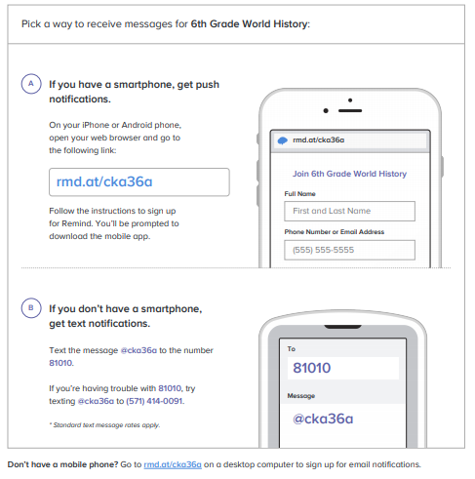

**Please sign and return this page ONLY to Mr. Friedman. The rest of the syllabus should be kept and used as a reference for you and your student.

I have read the 2018-2019 syllabus for World History and I understand my responsibilities as a student in this course and the requirements needed to maintain good academic standing.

____________________________________ _______________________________________
Student Name (Print) Student Signature

I have read the 2018-2019 syllabus for World History and I understand the long-term benefits of the skills and intellectual development offered by the course and support my student’s enrollment in this course. I understand that as a parent I may contact the instructor at any time and am encouraged to ask about my student’s progress.

____________________________________ _______________________________________
Parents/Guardian Name (Print) Parent/Guardian Signature

In an effort to make communications more effective and efficient, I would like to be able to contact all parties involved in your student’s education success. (Please print)

Contact Name Email Address Work/Cell

Contact Name Email Address Work/Cell

Contact Name Email Address Work/Cell

